Centralized Infrastructure Provisioning using Azure Automation and ARM Templates

Submitted in partial fulfillment of the requirements for the award of the degree of

Master of Computer Applications ((23ONMCR-753))
To

CENTRE FOR DISTANCE & ONLINE EDUCATION CHANDIGARH UNIVERSITY


Submitted by:
Vicky Chauhan
O24MCA110601
MCA



CENTRE FOR DISTANCE & ONLINE EDUCATION CHANDIGARH UNIVERSITY
Batch (2024-2026)

Certificate

I Vicky Chauhan (O24MCA110601) certify that the Major Project Report entitled “Centralized Infrastructure Provisioning using Azure Automation and ARM Templates” is done by me and it is an authentic work carried out by me at CENTRE FOR DISTANCE & ONLINE EDUCATION CHANDIGARH UNIVERSITY. The matter embodied in this project work has not been submitted earlier for the award of any degree or diploma to the best of my knowledge and belief.

Signature of the Student:
Vicky Chauhan

Date: 23/06/26

Certified that the Project Report (23ONMCR-753) entitled “Centralized Infrastructure Provisioning using Azure Automation and ARM Templates” done by the above students is completed under my guidance.

Countersigned: Director:
Signature of the Guide:
Date:
Name of the Guide:
Designation:

DECLARATION

This is to certify that the work which is being hereby presented by us in this project titled “Centralized Infrastructure Provisioning using Azure Automation and ARM Templates” in partial fulfilment of the award of the Master of Computer Applications submitted at the Department of Information Technology, Centre for Distance & Online Education Chandigarh University , is a genuine account of our work carried out during the period from August 2025 to December 2026.
The matter embodied in the project report to the best of our knowledge has not been submitted for the award of any other degree elsewhere.
Date: 23rd June 2026

Acknowledgement
We have given our efforts in this project. However, it would not have been possible without the kind support and help of many individuals and organizations. We would like to extend our sincere thanks to all of them.
We are highly indebted to Mentors for their guidance and constant supervision as well as for providing necessary information regarding the project & also for their support in completing the project.
We thank and appreciate the support provided by our college to complete the project within the given duration, also we would like to thank our college mates who helped us to achieve this feat.

ABSTRACT

Cloud infrastructure provisioning plays a vital role in ensuring efficient and reliable deployment of enterprise applications. Manual provisioning of cloud resources is often time-consuming, error-prone, and difficult to manage across multiple environments. This project presents a Centralized Infrastructure Provisioning System using Azure Automation and ARM Templates to automate the deployment and management of Azure resources.

The proposed solution uses Azure Automation Runbooks, Azure Resource Manager (ARM) Templates, Azure Storage, Managed Identity, and Role-Based Access Control (RBAC) to provision cloud infrastructure securely and consistently. ARM Templates implement the Infrastructure as Code (IaC) approach, enabling standardized and repeatable deployments. Azure Automation executes deployment workflows, while Azure Monitor and Log Analytics provide centralized monitoring and logging of deployment activities.

The system successfully automates the deployment of Azure resources such as Resource Groups, Storage Accounts, and Virtual Networks, reducing manual effort and minimizing deployment errors. The project demonstrates how cloud automation improves operational efficiency, enhances security, and supports DevOps practices through automated, scalable, and reliable infrastructure management.

Contents
Acknowledgement 4
Introduction 7
SDLC OF THE PROJECT 8

Introduction

Cloud computing has become an essential technology for organizations to deploy, manage, and scale IT infrastructure efficiently. With the increasing adoption of cloud platforms such as Microsoft Azure, organizations require automated and standardized methods to provision infrastructure while maintaining security, consistency, and compliance. Traditional manual deployment of cloud resources is time-consuming, prone to human error, and often leads to configuration inconsistencies across different environments.

Infrastructure as Code (IaC) has emerged as a modern approach that enables infrastructure to be defined, managed, and deployed through code rather than manual configuration. Microsoft Azure provides Azure Resource Manager (ARM) Templates, which allow organizations to create reusable and declarative templates for deploying cloud resources consistently. Combined with Azure Automation, these templates can be executed automatically through PowerShell Runbooks, reducing deployment time and improving operational efficiency.

This project, "Centralized Infrastructure Provisioning using Azure Automation and ARM Templates," focuses on developing an automated solution for provisioning Azure resources such as Resource Groups, Storage Accounts, and Virtual Networks. The solution utilizes Azure Automation Accounts, Managed Identity, Azure Storage, Role-Based Access Control (RBAC), Azure Monitor, and Log Analytics to create a secure and centralized infrastructure deployment framework. The use of Managed Identity eliminates the need to store credentials, while RBAC ensures that resources are accessed only by authorized users.

The implemented system provides a centralized platform for managing infrastructure deployments using reusable ARM templates and automated runbooks. It also integrates monitoring and logging services to track deployment status, identify failures, and maintain audit records. This approach reduces manual effort, improves deployment consistency, minimizes configuration drift, and supports enterprise DevOps practices.

The primary objective of this project is to demonstrate how Azure Automation and Infrastructure as Code can simplify cloud infrastructure management while ensuring scalability, security, and reliability. The developed solution provides a practical implementation of automated cloud provisioning that can be adopted by organizations to improve operational efficiency and standardize infrastructure deployment across multiple environments.

SDLC OF THE PROJECT

The Software Development Life Cycle (SDLC) is a structured process used for planning, designing, developing, testing, deploying, and maintaining software systems. For this project, Agile SDLC methodology was adopted because it supports iterative development, continuous improvement, and faster delivery of automation features. Each phase of the SDLC contributed to the successful implementation of the Azure Automation-based infrastructure provisioning system.

- Requirement Analysis

The first phase involved identifying the project requirements and understanding the problems associated with manual cloud infrastructure deployment. The following requirements were gathered:

- Automate Azure resource provisioning.
- Eliminate manual deployment errors.
- Implement Infrastructure as Code (IaC) using ARM Templates.
- Secure deployments using Managed Identity and RBAC.
- Enable centralized monitoring and logging.
- Provide a reusable and scalable deployment solution.

- System Design

In this phase, the overall architecture of the system was designed. The project components and their interactions were defined before implementation.

The system consists of:

- Azure Automation Account
- ARM Templates
- Azure Storage Account
- PowerShell Runbooks
- Managed Identity
- Azure Monitor
- Log Analytics Workspace
- Azure Resource Manager

The architecture ensures secure authentication, centralized template management, and automated deployment of Azure resources.

- Development

The development phase focused on implementing the designed solution. The following tasks were completed:

- Created an Azure Automation Account.
- Configured Managed Identity for secure authentication.
- Assigned RBAC permissions to the Automation Account.
- Created Azure Storage Account to store ARM Templates.
- Developed reusable ARM Templates for infrastructure deployment.
- Developed PowerShell Runbooks to automate template execution.
- Configured Azure Monitor and Log Analytics for centralized monitoring.

- Testing

After implementation, the solution was tested to verify its functionality and reliability.

Testing activities included:

- Validation of Automation Account configuration.
- Verification of Managed Identity authentication.
- ARM Template deployment testing.
- Resource Group creation testing.
- Storage Account deployment testing.
- Virtual Network deployment testing.
- Runbook execution testing.
- Monitoring and logging verification.

All deployment operations were successfully completed, and the expected Azure resources were provisioned without manual intervention.

- Deployment

The developed automation solution was deployed in the Microsoft Azure environment.
The deployment process involved:

- Uploading ARM Templates to Azure Storage.
- Publishing PowerShell Runbooks.
- Executing Runbooks from Azure Automation.
- Automatically provisioning Azure infrastructure.
- Monitoring deployment status through Azure Monitor and Log Analytics.

The deployment demonstrated consistent and repeatable infrastructure provisioning using Infrastructure as Code principles.

- Maintenance

The maintenance phase ensures that the automation framework remains reliable and up to date.
Future maintenance activities include:

- Updating ARM Templates based on new Azure services.
- Enhancing PowerShell Runbooks.
- Monitoring deployment performance.
- Applying Azure security updates.
- Optimizing resource provisioning and cost management.

- SDLC Flow Diagram

Requirement Analysis
│
▼
System Design
│
▼
Development
│
▼
Testing
│
▼
Deployment
│
▼
Maintenance

- Benefits of Using Agile SDLC

- Faster development and deployment.
- Continuous improvement through iterative updates.
- Easy integration of new Azure services.
- Better collaboration between development and operations teams.
- Improved project quality through continuous testing and monitoring.

The Agile SDLC approach enabled the project to be developed in a systematic manner while ensuring flexibility, scalability, and efficient infrastructure automation in the Microsoft Azure environment.

SYSTEM DESIGN

The design of the Centralized Infrastructure Provisioning using Azure Automation and ARM Templates project focuses on automating the deployment of Azure resources through a secure, reusable, and centralized architecture. The system follows the Infrastructure as Code (IaC) approach, where cloud resources are defined in ARM Templates and deployed automatically using Azure Automation Runbooks.

The architecture is modular, making it easy to maintain, extend, and reuse for future cloud deployments.

4.1 System Architecture

The overall architecture consists of the following components:

- Azure Automation Account
- Azure Storage Account
- ARM Templates
- PowerShell Runbooks
- Managed Identity
- Azure Resource Manager (ARM)
- Azure Resources
- Azure Monitor
- Log Analytics Workspace

Architecture Diagram

Administrator
│
▼
Azure Automation Account
│
Executes Runbook
│
▼
PowerShell Runbook
│
Reads ARM Template from Storage
│
▼
Azure Storage Account
│
▼
ARM Template (.json)
│
▼
Azure Resource Manager (ARM)
│
┌─────────────────┼─────────────────┐
▼ ▼ ▼
Resource Group Storage Account Virtual Network
│ │ │
└─────────────────┼─────────────────┘
▼
Azure Monitor & Log Analytics

4.2 Module Design

The project is divided into several independent modules.

- Azure Automation Module

This module is responsible for executing PowerShell Runbooks. It authenticates using Managed Identity and starts the deployment process automatically.

Responsibilities:

- Execute Runbooks
- Authenticate securely
- Trigger deployments
- Generate execution logs

- ARM Template Module

ARM Templates define the Azure resources that need to be deployed.

The template contains:

- Parameters
- Variables
- Resources
- Outputs

This enables reusable and standardized deployments.

- Storage Module

Azure Storage Account stores ARM Templates and deployment files.

Functions include:

- Store templates
- Download templates during execution
- Version management

- Deployment Module

This module provisions Azure resources using ARM Templates.

Resources deployed include:

- Resource Group
- Storage Account
- Virtual Network

The deployment is handled by Azure Resource Manager.

- Security Module

Security is implemented using:

- Managed Identity
- Azure Role-Based Access Control (RBAC)

Benefits:

- Password-less authentication
- Least privilege access
- Secure resource management

- Monitoring Module

Azure Monitor and Log Analytics continuously monitor deployment activities.

Functions include:

- Deployment status
- Error tracking
- Performance monitoring
- Log collection

4.3 Workflow Design

The deployment workflow consists of the following steps:

- Administrator starts the Automation Runbook.
- The Runbook authenticates using Managed Identity.
- ARM Template is downloaded from Azure Storage.
- Azure Resource Manager validates the template.
- Required Azure resources are provisioned.
- Deployment status is monitored.
- Logs are stored in Log Analytics.
- Administrator reviews deployment results.

Workflow Diagram

Start
│
▼
Launch Automation Runbook
│
▼
Authenticate using Managed Identity
│
▼
Download ARM Template
│
▼
Validate Template
│
▼
Deploy Azure Resources
│
▼
Monitor Deployment
│
▼
Store Logs
│
▼
End

4.4 Use Case Diagram

Actor: Cloud Administrator

Use Cases

- Upload ARM Template
- Execute Runbook
- Deploy Infrastructure
- Monitor Deployment
- View Logs
- Manage Azure Resources

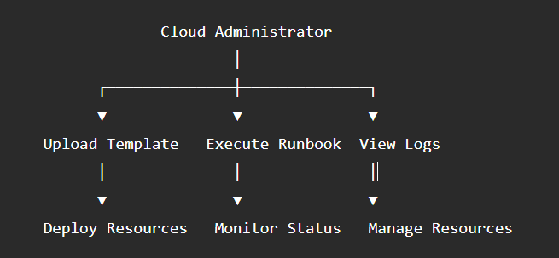

4.5 Sequence Diagram

Administrator
│
▼
Automation Account
│
▼
PowerShell Runbook
│
▼
Azure Storage
│
▼
ARM Template
│
▼
Azure Resource Manager
│
▼
Azure Resources
│
▼
Azure Monitor
│
▼
Deployment Completed

4.7 Design Advantages

The proposed design offers the following benefits:

- Automated and repeatable infrastructure deployment.
- Reduced manual effort and human errors.
- Secure authentication using Managed Identity.
- Reusable ARM Templates for consistent deployments.
- Centralized monitoring using Azure Monitor and Log Analytics.
- Easy scalability for deploying additional Azure resources.
- Improved governance through RBAC and Infrastructure as Code.

The modular architecture ensures that each component performs a specific responsibility, making the system easier to maintain, extend, and integrate with enterprise DevOps practices.

CHAPTER 5: CODING & IMPLEMENTATION

5.1 Overview

The implementation of this project focuses on automating Azure infrastructure provisioning using Azure Automation, ARM Templates, and PowerShell Runbooks. Instead of manually creating Azure resources, the project follows the Infrastructure as Code (IaC) approach, where ARM Templates define the required infrastructure and Azure Automation executes the deployment automatically. This approach ensures standardized, repeatable, and secure deployments across multiple environments.

5.2 Environment Preparation

Before implementation, the Azure environment was configured by creating the required resource group and monitoring workspace.

The following Azure CLI commands were used:

export RESOURCE_GROUP="rg-automation-demo"
export LOCATION="eastus"
export AUTOMATION_ACCOUNT="aa-infra-provisioning"
export LOG_ANALYTICS_WORKSPACE="law-automation-monitoring"

az group create \
--name ${RESOURCE_GROUP} \
--location ${LOCATION}

az monitor log-analytics workspace create \
--resource-group ${RESOURCE_GROUP} \
--workspace-name ${LOG_ANALYTICS_WORKSPACE}

These commands create the base infrastructure required for the automation solution.

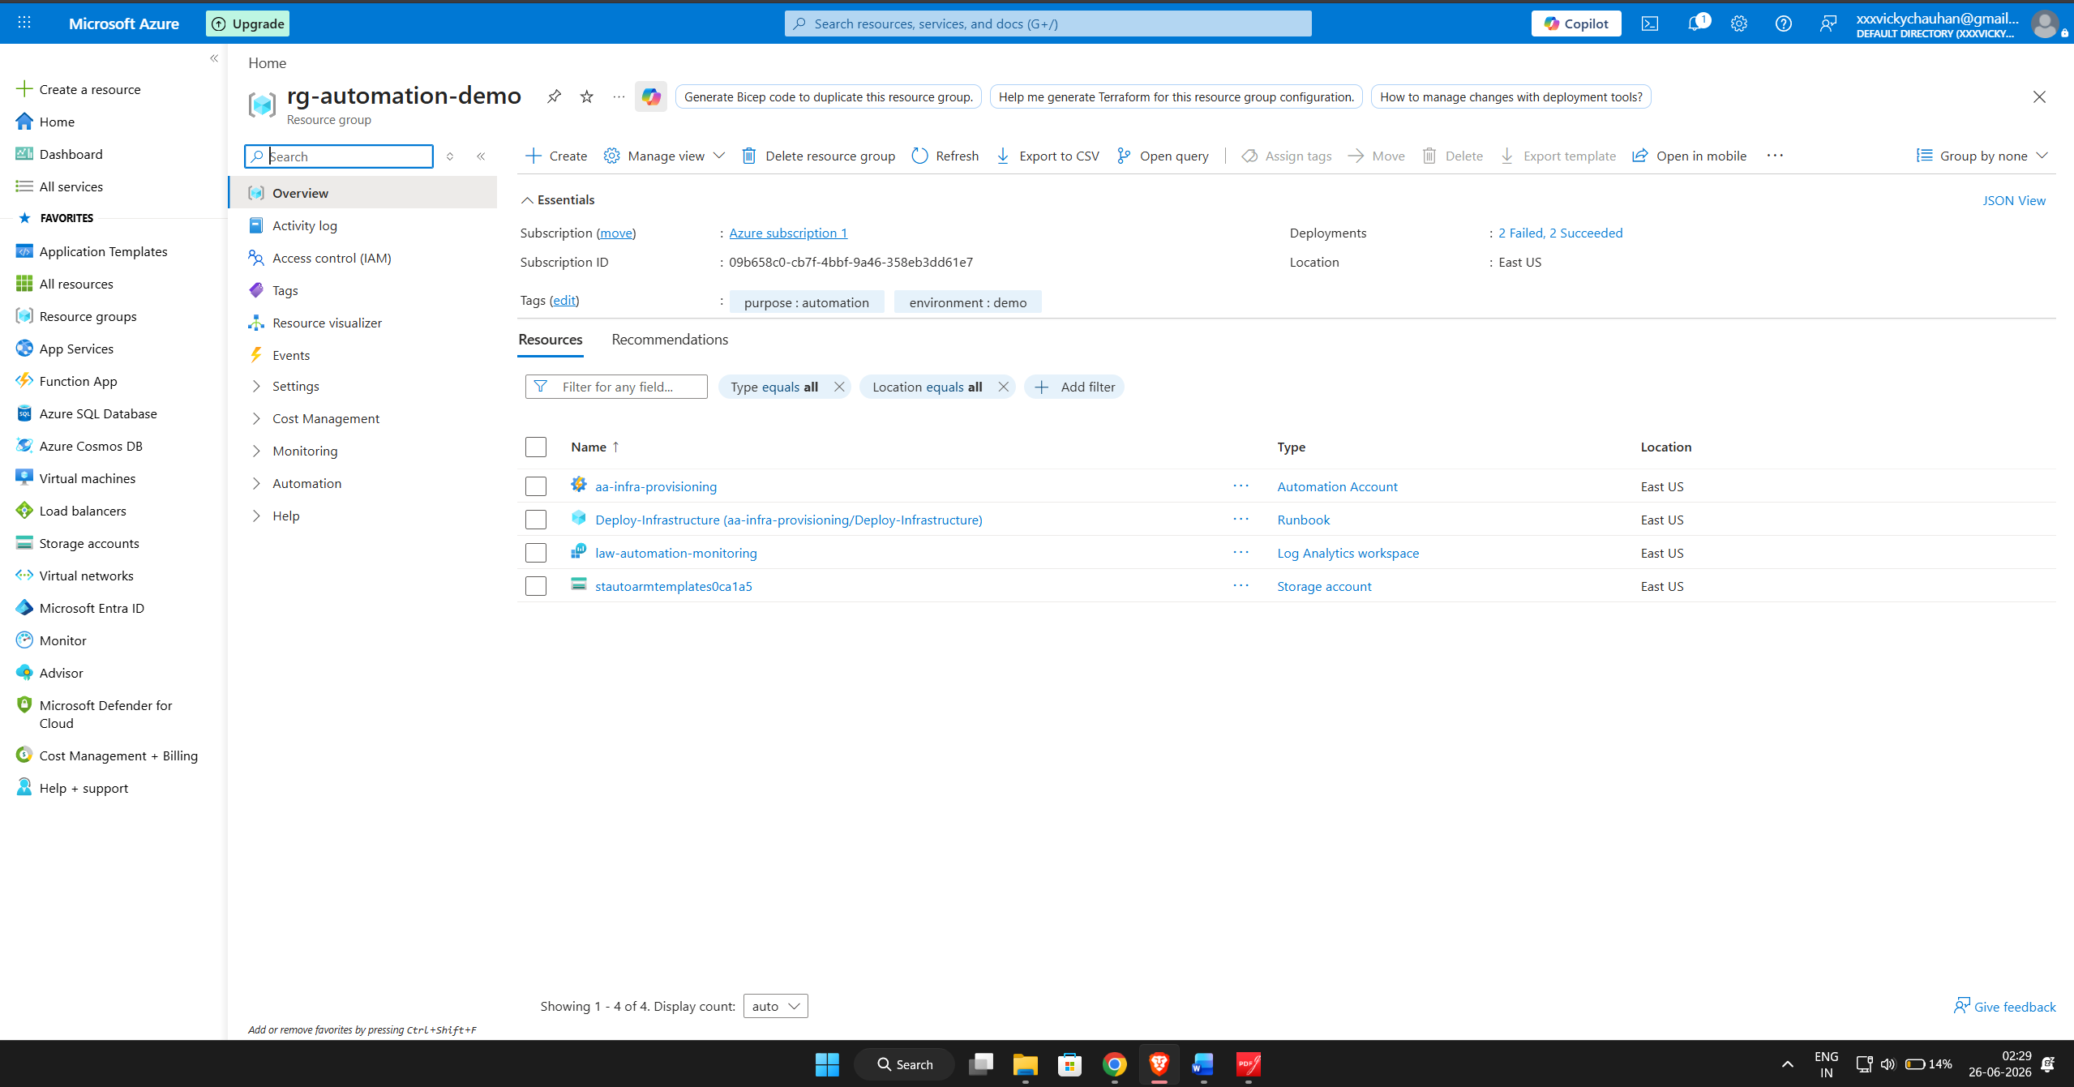

5.3 Azure Automation Account

An Azure Automation Account was created to execute PowerShell Runbooks responsible for infrastructure deployment.

az automation account create \
--resource-group ${RESOURCE_GROUP} \
--name ${AUTOMATION_ACCOUNT} \
--location ${LOCATION} \
--assign-identity

The Automation Account was configured with a System Assigned Managed Identity, allowing secure authentication without storing credentials.

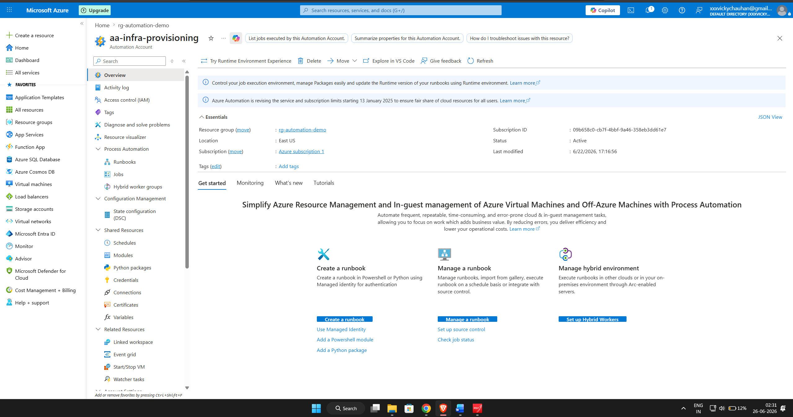

5.4 Azure Storage Account

A dedicated Azure Storage Account was created to centrally store ARM Templates used during deployment.

az storage account create \
--name ${STORAGE_ACCOUNT} \
--resource-group ${RESOURCE_GROUP} \
--location ${LOCATION} \
--sku Standard_LRS

A file share named arm-templates was created, and the infrastructure template was uploaded.

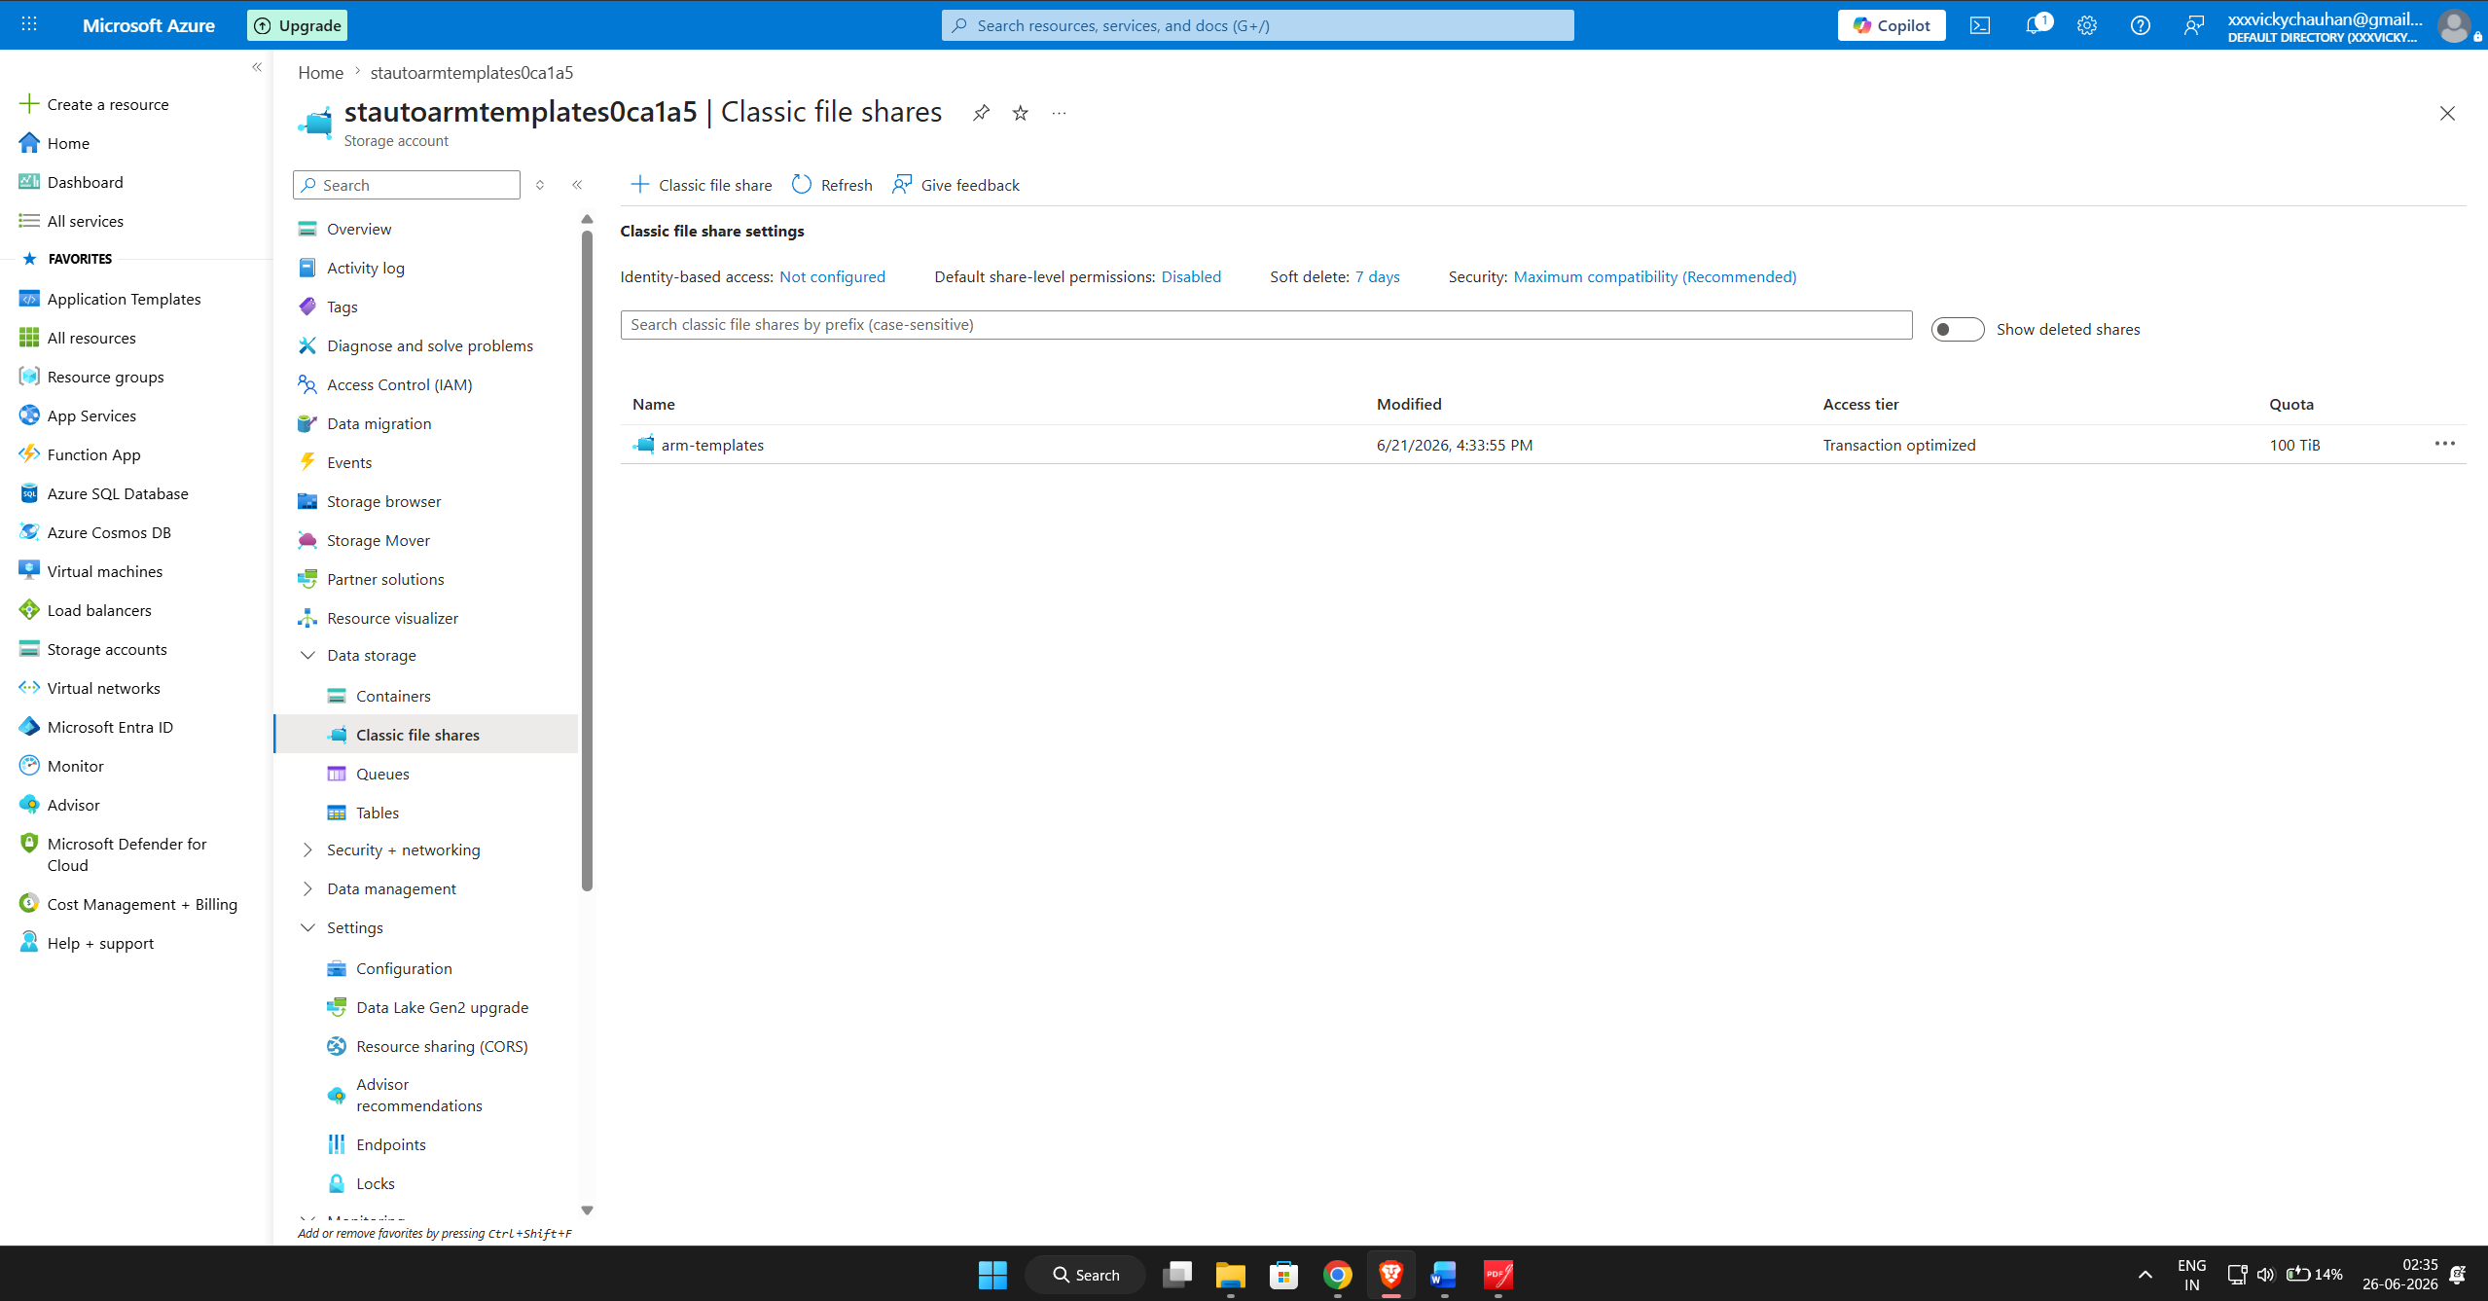

5.5 Role-Based Access Control (RBAC)

To enable secure deployment, the Managed Identity associated with the Automation Account was assigned the Contributor role on the deployment Resource Group.

az role assignment create \
--assignee ${MANAGED_IDENTITY_ID} \
--role "Contributor" \
--scope "/subscriptions/${SUBSCRIPTION_ID}/resourceGroups/${RESOURCE_GROUP}"

This allows the Runbook to create and manage Azure resources while following the principle of least privilege.

5.6 ARM Template Implementation

The infrastructure was defined using an ARM Template written in JSON format.

The template provisions:
- Storage Account
- Virtual Network
- Subnet
- Deployment Outputs

The template uses:
- Parameters
- Variables
- Resources
- Outputs

Example:

{
"$schema":"https://schema.management.azure.com/schemas/2019-04-01/deploymentTemplate.json#",
"parameters": {},
"variables": {},
"resources": [],
"outputs": {}
}

The completed template was uploaded to Azure Storage and later retrieved by the Runbook for deployment.

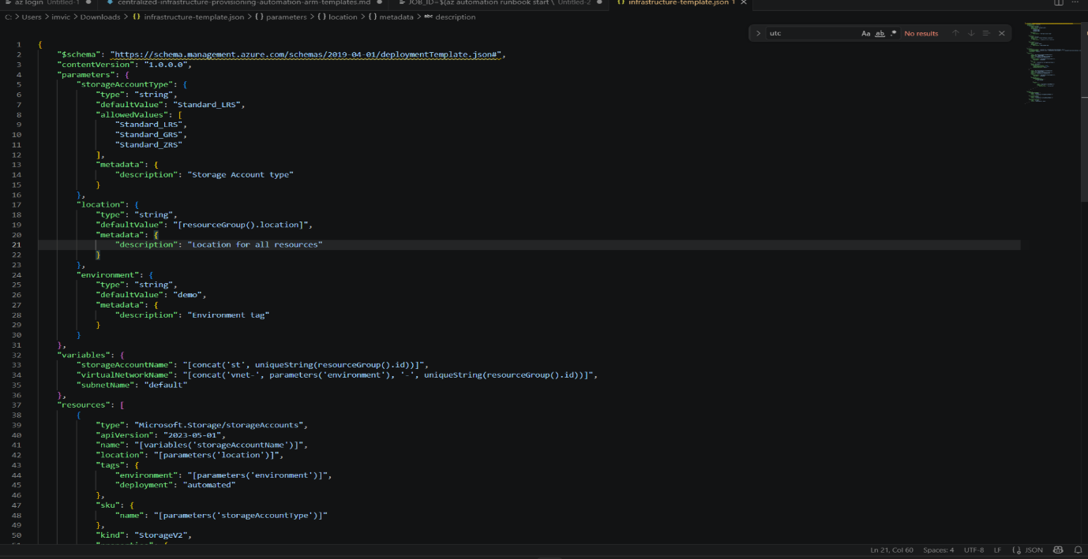

5.7 PowerShell Runbook

A PowerShell Runbook named Deploy-Infrastructure was developed to automate the deployment process.

The Runbook performs the following operations:

- Authenticates using Managed Identity
- Downloads the ARM Template
- Creates deployment parameters
- Executes the ARM deployment
- Logs deployment status
- Handles deployment failures

Key PowerShell commands used:

Disable-AzContextAutosave -Scope Process

Connect-AzAccount -Identity

New-AzResourceGroupDeployment `
-ResourceGroupName $ResourceGroupName `
-TemplateFile $TemplateFile `
-TemplateParameterObject $DeploymentParams

The Runbook also includes exception handling to capture errors and provide deployment status messages.

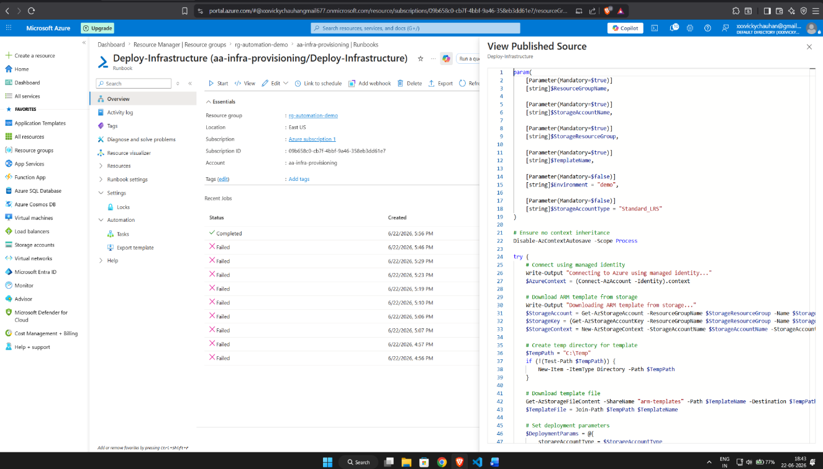

5.8 Runbook Execution

After publishing the Runbook, it was executed from the Azure Automation Account.
The deployment job was started using:

az automation runbook start \
--resource-group ${RESOURCE_GROUP} \
--automation-account-name ${AUTOMATION_ACCOUNT} \
--name "Deploy-Infrastructure"

The execution successfully deployed the required Azure resources and generated detailed execution logs.

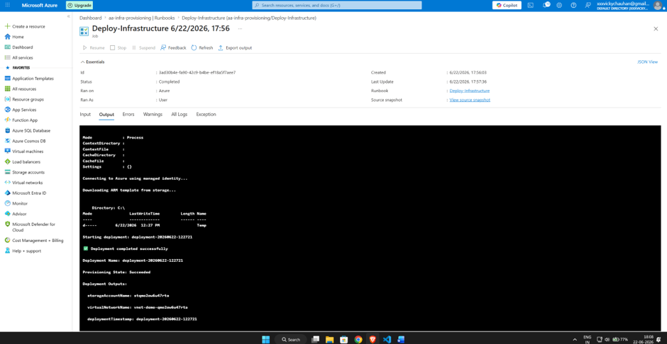

5.9 Resource Deployment

Upon successful execution, the ARM Template automatically provisioned the following resources:

Azure Resource | Status
Resource Group | Successfully Created
Storage Account | Successfully Created
Virtual Network | Successfully Created
The deployed resources were verified through the Azure Portal.

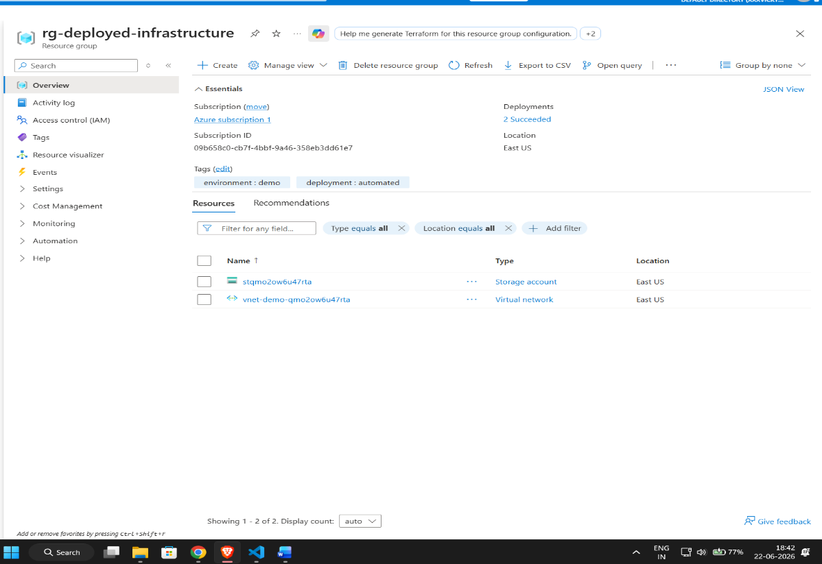
5.10 Monitoring and Logging

Azure Monitor and Log Analytics Workspace were integrated to collect deployment logs and monitor infrastructure health.

The monitoring system provides:
- Deployment history
- Runbook execution logs
- Error tracking
- Resource monitoring
- Performance metrics

This enables administrators to monitor deployment status and troubleshoot issues efficiently.

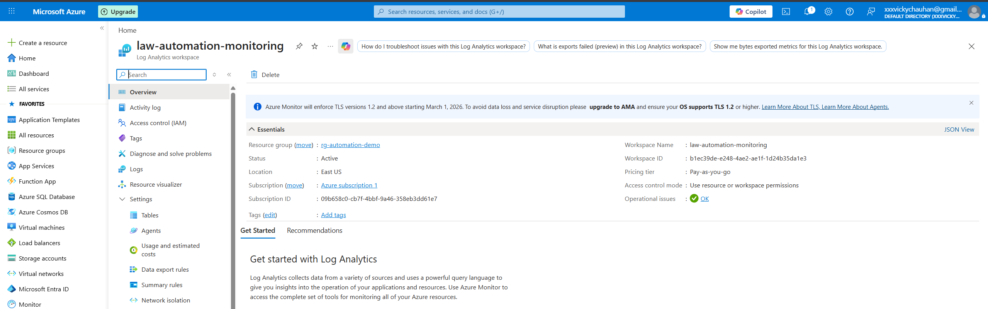

5.11 Summary

The implementation successfully automated Azure infrastructure provisioning using Azure Automation and ARM Templates. The use of Infrastructure as Code reduced manual effort, improved deployment consistency, enhanced security through Managed Identity and RBAC, and enabled centralized monitoring through Azure Monitor and Log Analytics. The developed solution demonstrates an enterprise-ready approach to cloud infrastructure automation and can be extended to support additional Azure resources and multi-environment deployments.

CHAPTER 6: TESTING

6.1 Introduction

Testing is an essential phase of the Software Development Life Cycle (SDLC) that verifies whether the developed system meets the specified functional and non-functional requirements. In this project, testing was performed to validate the automated infrastructure provisioning process using Azure Automation, ARM Templates, and PowerShell Runbooks. The objective was to ensure that Azure resources were deployed successfully, securely, and consistently without manual intervention.
The testing process included functional testing, security testing, deployment validation, and monitoring verification.

6.2 Testing Objectives

The main objectives of testing were:

- Verify successful execution of Azure Automation Runbooks.
- Validate ARM Template deployment.
- Ensure Azure resources are provisioned correctly.
- Verify Managed Identity authentication.
- Confirm RBAC permissions are correctly assigned.
- Validate monitoring and logging functionality.
- Ensure deployment consistency and reliability.

6.3 Types of Testing Performed

- Functional Testing

Functional testing was performed to verify that each component of the automation solution worked as expected.

The following functionalities were tested:

- Azure Automation Account creation
- ARM Template upload
- Runbook execution
- Resource deployment
- Monitoring configuration

Result: All functional tests passed successfully.

2. Security Testing
Security testing verified secure authentication and authorization mechanisms.
The following were validated:
- Managed Identity authentication
- Role-Based Access Control (RBAC)
- Secure access to Azure Storage
- Password-less authentication
Result: Authentication and authorization worked successfully without exposing credentials.

3. Deployment Testing
Deployment testing ensured that Azure resources were provisioned automatically using ARM Templates.
Resources validated:
- Resource Group
- Storage Account
- Virtual Network
Result: Infrastructure was successfully deployed through Azure Automation.

4. Monitoring Testing

Azure Monitor and Log Analytics were tested to verify deployment logs and execution history.

The following were monitored:
- Runbook execution status
- Deployment logs
- Error messages
- Resource provisioning status
Result: Monitoring services successfully recorded deployment activities.

  - Validation & Testing

After implementing the automated infrastructure provisioning solution, several validation tests were performed to verify that all Azure resources were configured correctly and that the deployment process executed successfully. The validation was carried out using Azure CLI commands and Azure Portal.

6.6 Verify Azure Automation Account Configuration

The following commands were used to verify the Automation Account configuration and Managed Identity status.

# Check automation account status
az automation account show \
--resource-group ${RESOURCE_GROUP} \
--name ${AUTOMATION_ACCOUNT} \
--query "{name:name,state:state,location:location}" \
--output table

# Verify managed identity configuration
az automation account show \
--resource-group ${RESOURCE_GROUP} \
--name ${AUTOMATION_ACCOUNT} \
--query "identity.type" \
--output tsv

Expected Result:

- Automation Account is displayed successfully.
- State is Succeeded.
- Managed Identity type is System Assigned.
Actual Result :

The Automation Account aa-infra-provisioning was successfully created with a System Assigned Managed Identity, confirming secure authentication for automated deployments.

6.6.2 Verify ARM Template Storage Access

To ensure that the deployment template was correctly uploaded and accessible, the following commands were executed.

# List ARM templates in storage
az storage file list \
--share-name arm-templates \
--account-name ${STORAGE_ACCOUNT} \
--account-key ${STORAGE_KEY} \
--output table

# Download ARM template
az storage file download \
--share-name arm-templates \
--path infrastructure-template.json \
--dest ./downloaded-template.json \
--account-name ${STORAGE_ACCOUNT} \
--account-key ${STORAGE_KEY}

Expected Result

ARM Template appears in the Azure File Share.
Template downloads successfully.

Actual Result

The file infrastructure-template.json was successfully uploaded to Azure Storage and downloaded without any errors, confirming that the template repository was correctly configured.

6.6.3 Validate Runbook Execution

The deployment Runbook was executed and its output was verified using Azure CLI.

# Check job output
az automation job output \
--resource-group ${RESOURCE_GROUP} \
--automation-account-name ${AUTOMATION_ACCOUNT} \
--job-id ${JOB_ID}

# Verify deployed resources
az resource list \
--resource-group ${TARGET_RESOURCE_GROUP} \
--output table

Expected Result

- Runbook execution completes successfully.
- Azure resources are deployed automatically.

Actual Result

The Deploy-Infrastructure Runbook completed successfully and provisioned the required Azure resources, including the Resource Group, Storage Account, and Virtual Network. The deployment logs confirmed successful execution.

6.6.4 Verify Deployment Rollback Capability

The deployment history was reviewed to validate deployment status and rollback support.

# List deployment history
az deployment group list \
--resource-group ${TARGET_RESOURCE_GROUP} \
--query "[].{name:name,state:properties.provisioningState,timestamp:properties.timestamp}" \
--output table

# Verify latest deployment
DEPLOYMENT_NAME=$(az deployment group list \
--resource-group ${TARGET_RESOURCE_GROUP} \
--query "[0].name" \
--output tsv)

az deployment group show \
--resource-group ${TARGET_RESOURCE_GROUP} \
--name ${DEPLOYMENT_NAME} \
--query "properties.provisioningState" \
--output tsv

Expected Result

- Deployment history displays completed deployments.
- Provisioning State is Succeeded.
- Rollback information is available for future recovery if required.

Actual Result

The deployment history confirmed that the infrastructure deployment completed successfully with a Succeeded provisioning state. This validated that the deployment process executed correctly and that deployment history could be used for future recovery and auditing.

6.6.5 Validation Summary

Validation Item | Status
Automation Account Configuration | ✅ Passed
Managed Identity Verification | ✅ Passed
ARM Template Storage Access | ✅ Passed
PowerShell Runbook Execution | ✅ Passed
Resource Deployment Verification | ✅ Passed
Deployment History Validation | ✅ Passed
Azure Monitor & Log Analytics Verification | ✅ Passed
The validation process confirmed that the implemented Azure Automation solution functioned as expected. All deployment stages were completed successfully, infrastructure resources were provisioned automatically, and centralized monitoring and logging were operational, demonstrating the reliability and effectiveness of the proposed Infrastructure as Code (IaC) solution.

CHAPTER 7: APPLICATIONS

7.1 Applications

The Centralized Infrastructure Provisioning using Azure Automation and ARM Templates project has significant applications in organizations that rely on Microsoft Azure for managing their cloud infrastructure. By automating infrastructure deployment, the solution minimizes manual effort, reduces deployment time, and ensures consistency across different environments.

The major applications of the proposed system are as follows:

- Enterprise Cloud Infrastructure

Large organizations can use the solution to automatically provision Azure resources such as Virtual Networks, Storage Accounts, Virtual Machines, and Resource Groups while maintaining standardized configurations.

- DevOps Automation

The project supports DevOps practices by enabling Infrastructure as Code (IaC). ARM Templates can be integrated with Azure DevOps or GitHub Actions to automate infrastructure deployment during Continuous Integration and Continuous Deployment (CI/CD) pipelines.

- Multi-Environment Deployment

The same ARM Templates can be reused to deploy Development, Testing, Staging, and Production environments with minimal configuration changes, ensuring consistency across all environments.

- Infrastructure Standardization

Organizations can enforce predefined infrastructure standards by using reusable ARM Templates, reducing configuration drift and ensuring compliance with organizational policies.

- Cloud Governance

Azure Automation combined with RBAC and Managed Identity provides centralized governance by controlling user permissions, monitoring deployment activities, and maintaining audit logs.

- Disaster Recovery and Business Continuity

The automated deployment process enables organizations to recreate infrastructure quickly during disaster recovery scenarios, reducing downtime and improving business continuity.

- Cost Optimization

Automated deployments reduce manual operational costs and eliminate unnecessary resource provisioning, allowing organizations to optimize cloud resource utilization.

8. Educational and Research Purposes
The project serves as a practical implementation of Cloud Computing, Infrastructure as Code, Azure Automation, and DevOps concepts, making it valuable for academic learning and research.

Advantages of the Developed System:

- Automated infrastructure provisioning
- Reduced manual intervention
- Secure authentication using Managed Identity
- Centralized monitoring and logging
- Standardized and reusable deployments
- Improved deployment consistency
- Scalable cloud infrastructure management
- Easy integration with CI/CD pipelines

The proposed solution is suitable for organizations seeking secure, scalable, and automated cloud infrastructure management while adopting modern DevOps practices.

CHAPTER 8: CONCLUSION

Conclusion

This project successfully developed and implemented a Centralized Infrastructure Provisioning System using Azure Automation and ARM Templates for automating the deployment of cloud infrastructure in Microsoft Azure. The solution demonstrates how Infrastructure as Code (IaC) can simplify resource provisioning while improving consistency, security, and operational efficiency.

Azure Automation Runbooks were used to execute deployment workflows, while ARM Templates defined the cloud infrastructure in a reusable and standardized format. The integration of Managed Identity and Role-Based Access Control (RBAC) ensured secure authentication and authorization without storing sensitive credentials. Azure Storage served as a centralized repository for deployment templates, whereas Azure Monitor and Log Analytics provided continuous monitoring and logging of deployment activities.

The implemented system successfully automated the deployment of Azure resources, including Resource Groups, Storage Accounts, and Virtual Networks. Functional testing and validation confirmed that the deployment process executed successfully and that all resources were provisioned correctly.

The project significantly reduced manual effort, minimized deployment errors, and improved infrastructure consistency. It also demonstrated the practical implementation of DevOps principles and Infrastructure as Code within a cloud environment. The developed solution can be extended to support additional Azure services, multi-environment deployments, CI/CD integration, and advanced governance policies, making it suitable for enterprise-scale cloud infrastructure management.

CHAPTER 9: BIBLIOGRAPHY (APA Style)

- Microsoft. (2025). Azure Automation Documentation. Retrieved from https://learn.microsoft.com/azure/automation/
- Microsoft. (2025). Azure Resource Manager Templates Documentation. Retrieved from https://learn.microsoft.com/azure/azure-resource-manager/templates/
- Microsoft. (2025). Azure CLI Documentation. Retrieved from https://learn.microsoft.com/cli/azure/
- Microsoft. (2025). Azure Storage Documentation. Retrieved from https://learn.microsoft.com/azure/storage/
- Microsoft. (2025). Azure Monitor Documentation. Retrieved from https://learn.microsoft.com/azure/azure-monitor/
- Microsoft. (2025). Log Analytics Documentation. Retrieved from https://learn.microsoft.com/azure/azure-monitor/logs/
- Microsoft. (2025). Managed Identity Documentation. Retrieved from https://learn.microsoft.com/azure/active-directory/managed-identities-azure-resources/
- Microsoft. (2025). Role-Based Access Control (RBAC) Documentation. Retrieved from https://learn.microsoft.com/azure/role-based-access-control/
- Kim, G., Humble, J., Debois, P., & Willis, J. (2021). The DevOps Handbook (2nd ed.). IT Revolution Press.
- Morris, K. (2020). Infrastructure as Code (2nd ed.). O'Reilly Media.
- Richards, M., & Ford, N. (2020). Fundamentals of Software Architecture. O'Reilly Media.
- Sommerville, I. (2016). Software Engineering (10th ed.). Pearson Education.
- Pressman, R. S., & Maxim, B. R. (2020). Software Engineering: A Practitioner's Approach (9th ed.). McGraw-Hill Education.
- NIST. (2020). Cloud Computing Synopsis and Recommendations. National Institute of Standards and Technology.
- Azure Architecture Center. (2025). Microsoft Azure Well-Architected Framework. Retrieved from https://learn.microsoft.com/azure/architecture/framework/

